Cyber Tech External Documentation

Nisarg Patel (200292593)

Jinal Patel (200299533)

Mansi Patel (200303640)

Enterprise Computing

Tom Tsiliopoulos

Friday, August 19, 2016

**Table of contents**

Logo Image 3

Detailed description 4

Version History 4

Wireframes Section 5-6

Home Page 7

About Page 8

Contact Page 9

Shop Page 10

Products Page 11

Description Page 12

Cart Page 13

Screen Capture Section 14-15

Logo:-  
  
This is Our Web Site Logo.



Detailed description:-

Game Tracker

Who we are

Providing Computer Accessories to the people who want to make more happen is what we do. But who we are is something much more important. Over the past 4 months, we’ve worked hard to build a powerful brand that people connect with, trust and believe in.

We are here to provide customer satisfaction by providing great e-commerce website where users can find products related to Computer Accessories and order it online. We also have contact page where user can talk to us and ask any question related to their order or a product they would like on our website.

Version History:-

Git hub Link: - https://github.com/Nisarg1503/CyberTechFinal

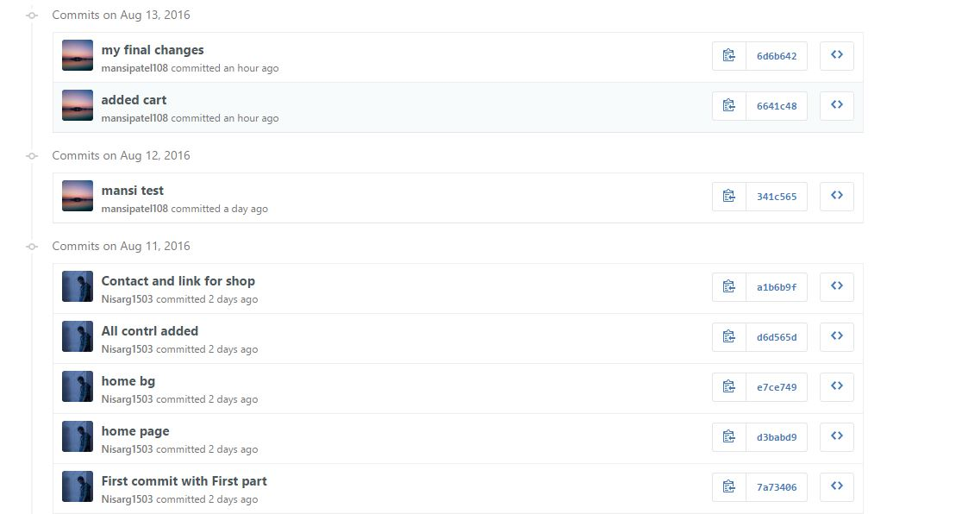

Wireframes Section:-

Home Page:

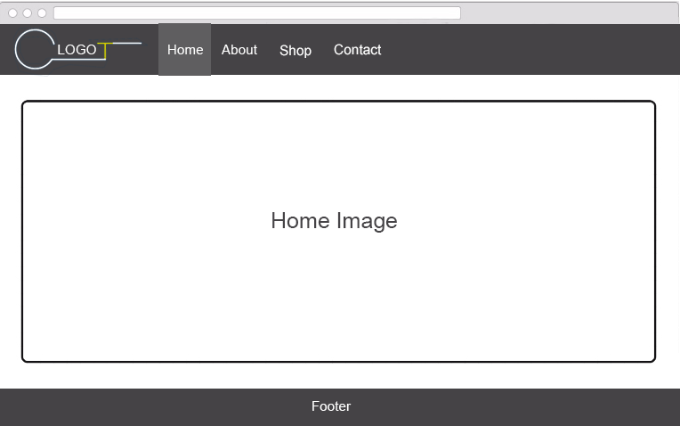

About Page:-

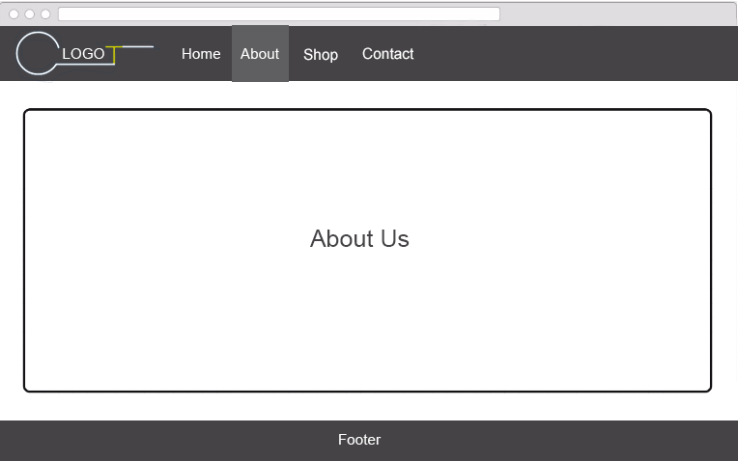

Contact Page:-

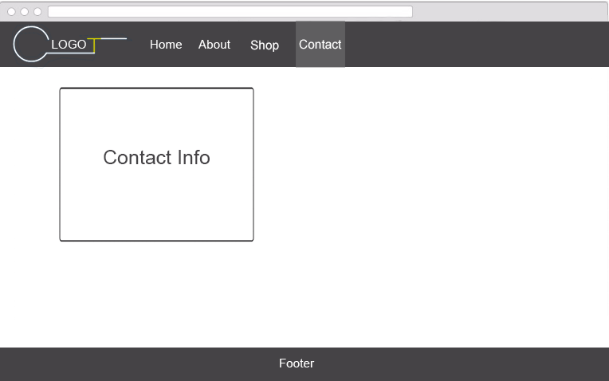

Shop page:-

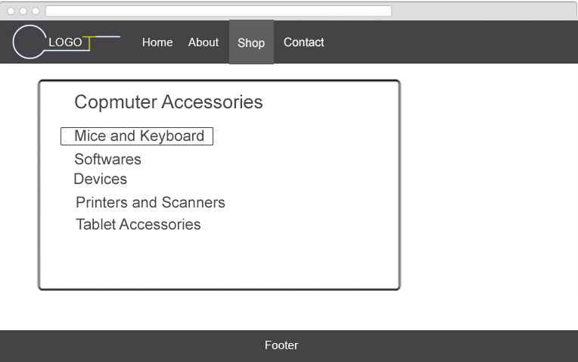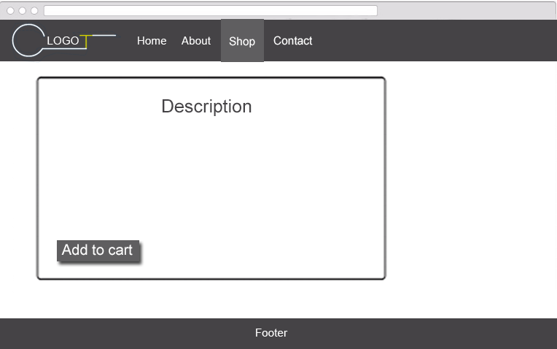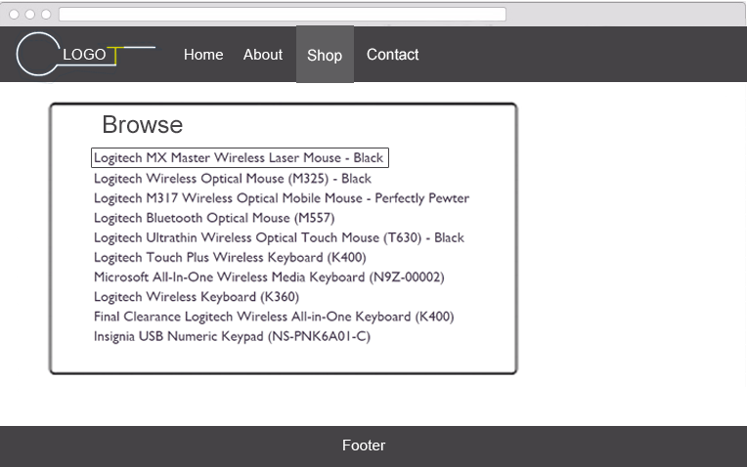

Screen Capture Section:-

This is the Screen shots of our Home, About, Contact, Shop, Product Page.

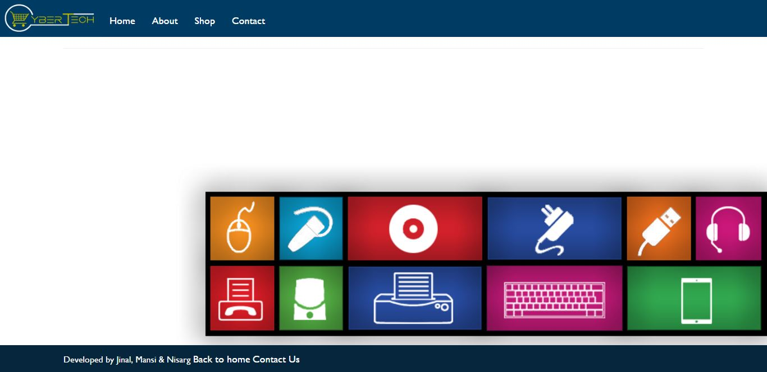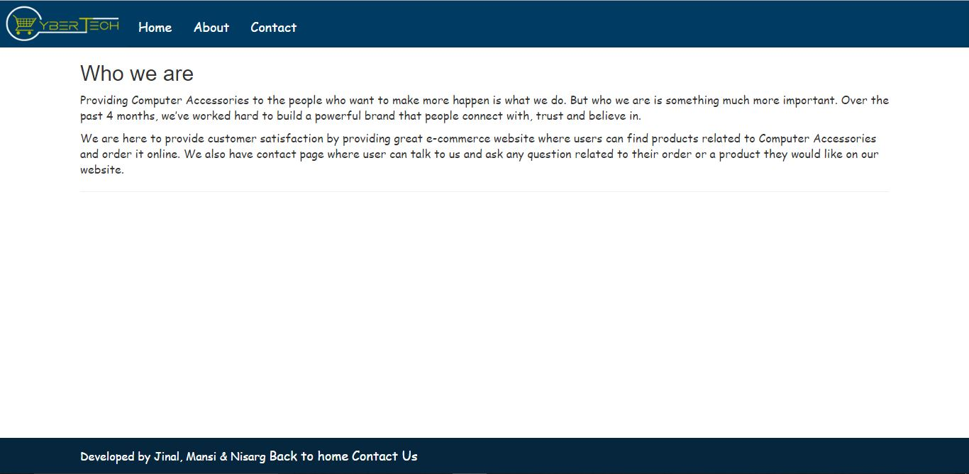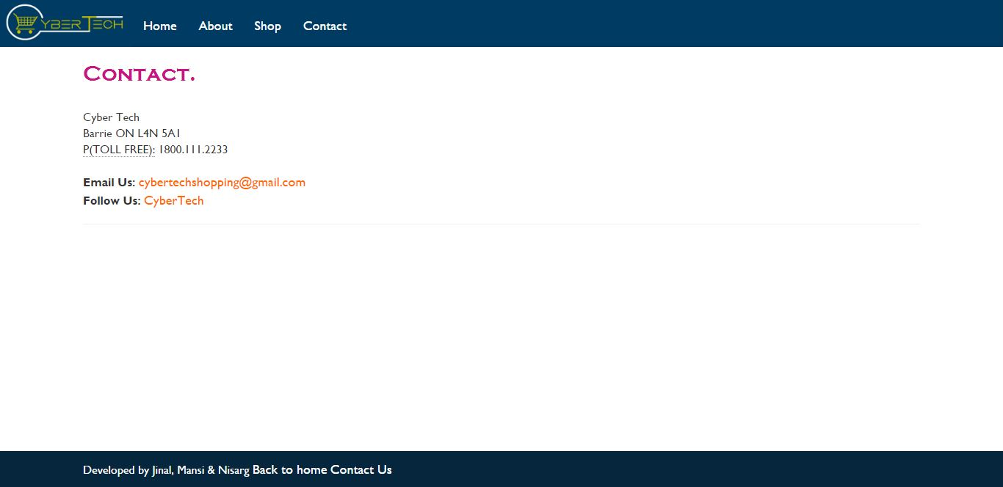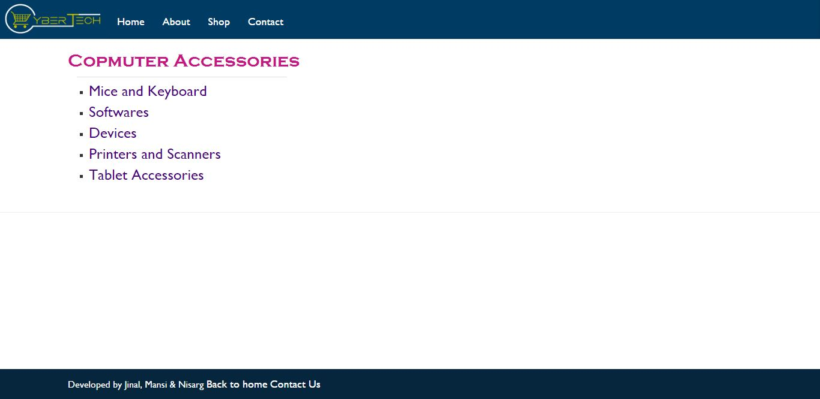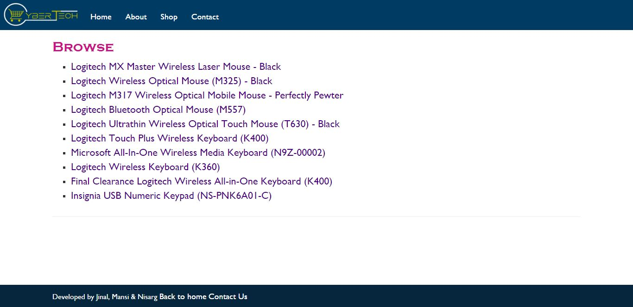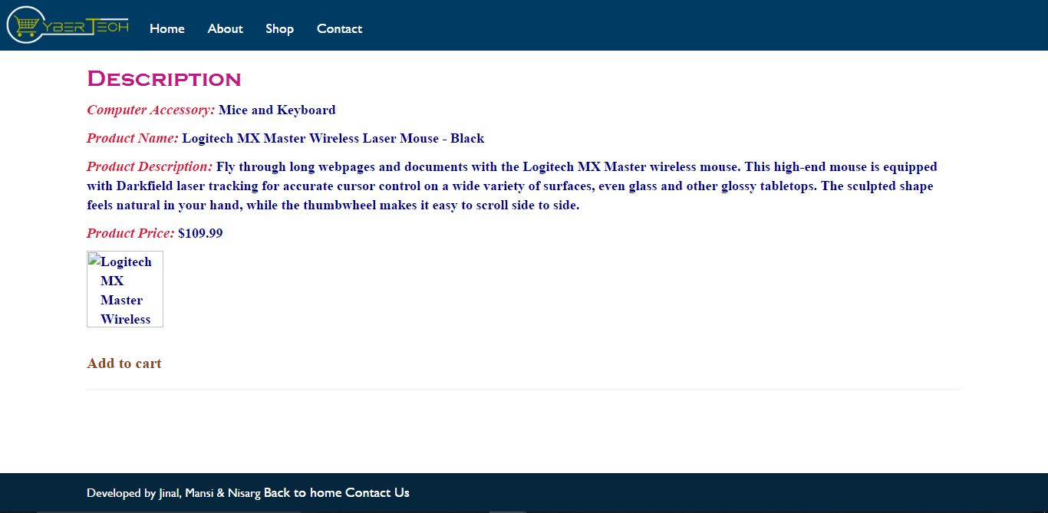

Cart Page: -

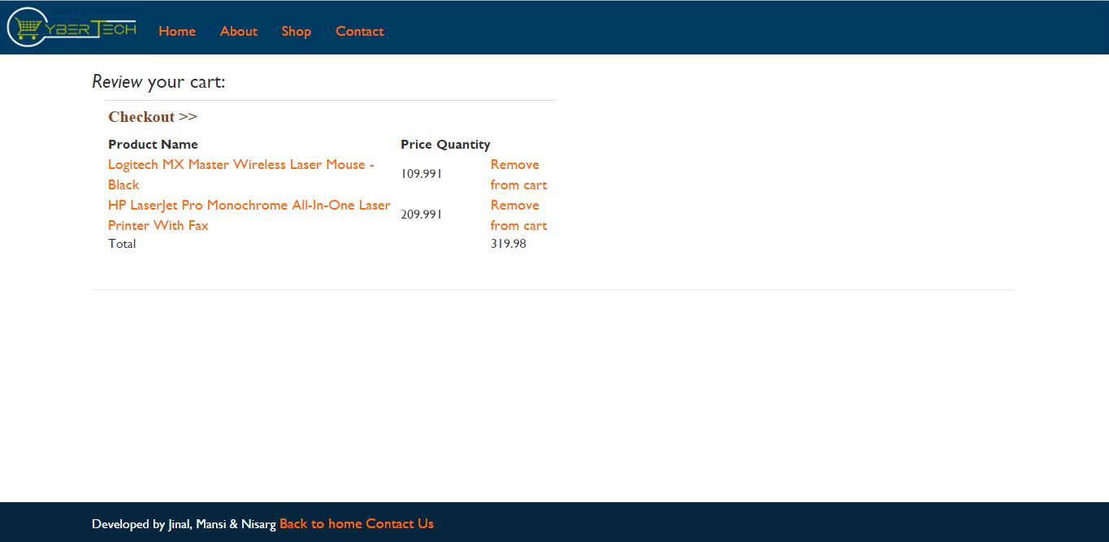

Thank you!